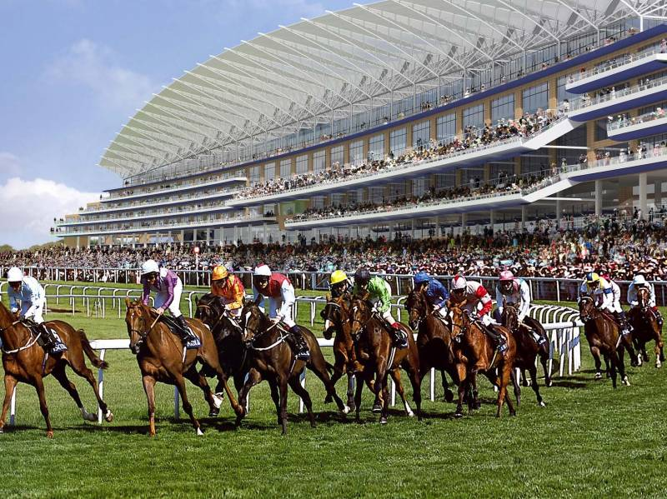

# Horse Racing at Ascot Property Race Day

# Hosted by Cromwell Property Holdings

Friday 14th July 2017

Arrival: Noon

Lunch: From 1pm

Last Race: 5.50pm

Close: 6pm

## Cost £70.00 per person, to include buffet lunch and drinks. We are being hosted in a private box opposite the race finish line.

Please reserve me ……….place/s for the Ascot Property Race day with Cromwell Property Holdings

Name………………………………………………Company…………………………………………………………………………..…

Guest’s Name/Company……………………………………………………………………………………………………………….

Payment online preferably please to:

The 100 Property Club - Sort Code: 20-46-73

Account Number: 9002 0656

Reference: Your surname/Ascot

To confirm your booking please return this completed form to David Bowen at david@wandi.co.uk