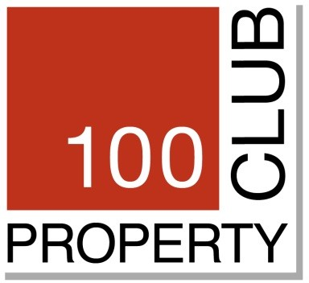

# Tuesday 12 June 2018 at Hush, Mayfair

**63rd Club Lunch followed by AGM**

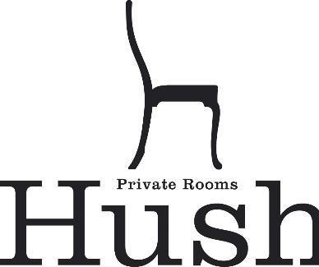

## Lancashire Court, 8 Brook St, London W1S 1EY <http://www.hush.co.uk/>

12:30hrs meet for a pre-lunch glass of bubbly (included) 13:00hrs lunch – The AGM will follow lunch for those wishing to attend

(Members and guests are requested to run a separate tab for any extra food or drinks. Please ensure any such arrangements are made clear to the restaurant and all bills settled before departure to avoid the club having to settle and pursue the culprits.)

**£65 per head**

**to include a three course lunch and wine**

**Please reserve me ….… place/s for the *‘63rd Club Lunch’* at**

***‘Hush, Mayfair* on *‘12/06/18***

### Name Company

Guest’s Name / Company

Set menu – please advise of any dietary requirements.

# Please pay by BACS Transfer as below:

BACS Transfer: The 100 Property Club – Sort Code: 20-46-73 Account Number: 9002 0656 Reference: yoursurname/58clublunch

Any queries tel: 01732 780101 or e-mail [jofarr@barlowrobbins.com](mailto:jofarr@barlowrobbins.com) or [tbaker@milton-investment.co.uk](mailto:tbaker@milton-investment.co.uk)