

# T20 Blast Middlesex versus Surrey

Thursday 13th July 2017

at

Lord’s Cricket Ground

St John's Wood Road, London NW8 8QN

**Play commences at 6.15pm**

**Cost £20.00 per ticket**

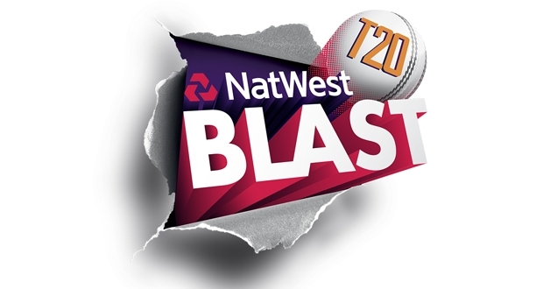

I would like to book **…….** tickets to the T20 Blast cricket on the 13th July 2017

Name: Company:

Guest/’s Name: Company:

Tickets posted to (Following payment):

Payment online preferably please to:

The 100 Property Club - Sort Code: 20-46-73 Account Number: 9002 0656

Reference: Your surname/t20/130717

Any queries, please speak to David Bowen 01276 682 501 or [david@wandi.co.uk](mailto:david@wandi.co.uk)